Metal Fasteners
  - Key Revision Facts: GCSE Technology

Name | Characteristics | Image
Bolts - The bolt consists of a head and a cylindrical body with screw threads along a portion of its length.  Bolts are typically used with nuts and washers with a clearance hole to join two pieces together. | The head usually has a hexagon profile. | 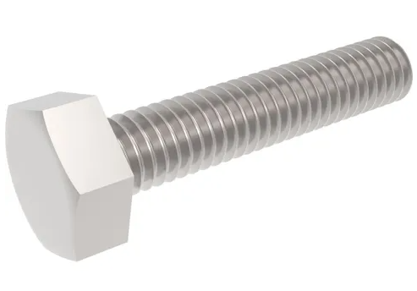
Nut – A nut has internal threads to match those of a bolt. | Usually have a hexagon profile. Used with bolts and machine screws to apply pressure | 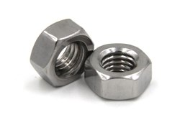
Nylon Lock Nut - A lock nut with a plastic insert that resists loosening | Single-use, vibration resistant. | 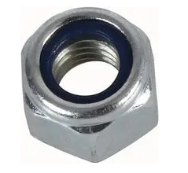
Machine Screw - a fastening device similar to a bolt but having a socket in its head, allowing it to be turned with a screwdriver.  Machine screws are typically used with a threaded hole to secure two parts together. | Many different driving methods and diverse profiles. | 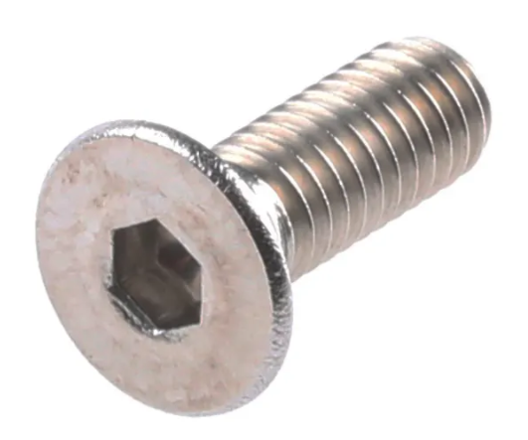
Pop Rivet - a tubular rivet inserted into a hole and clinched by the withdrawing of a central rod, used where only one side of the work is accessible. | Semi-permanent joining of two or more pieces. | 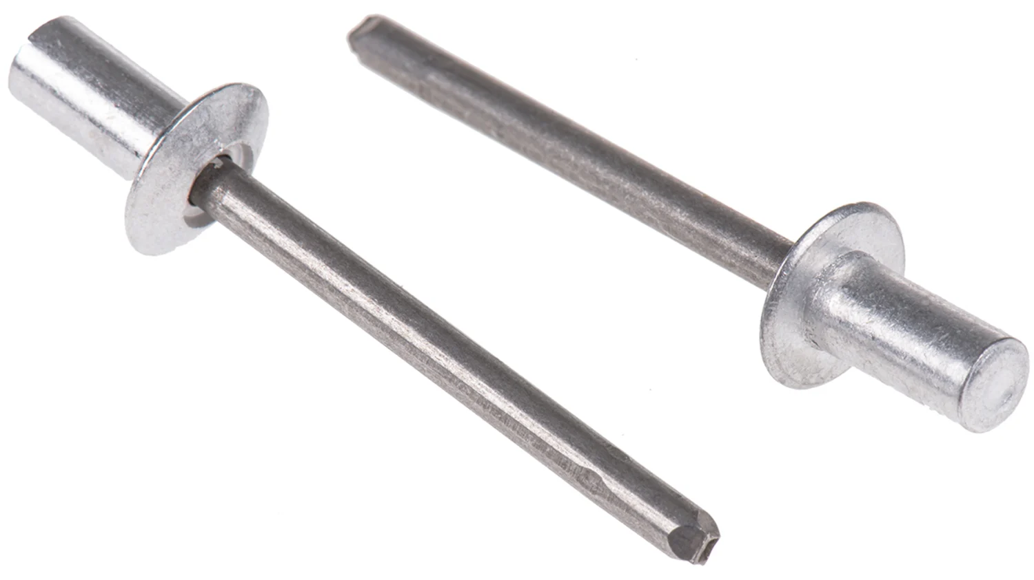
Snap Rivet - consist of a Male and Female component that snap together with finger pressure and provide a neat appearance on both sides of the assembly | Semi-permanent joining of two or more pieces. | 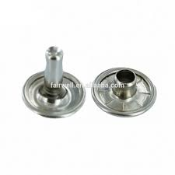
Washer - ring fixed between two joining surfaces or between a nut and a bolt to spread the pressure or act as a spacer or seal. | Flat disc shape with a hole. | 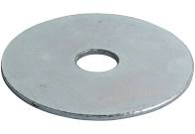

Download
More Key Fact Revision sheets can be downloaded from
www.andrew-seaford.co.uk/revision

Version information
Date | Arthur | Comment
13-Mar-2021 | Andrew Seaford | Initial release.

